Alstonville Anglicans

Welcome
You might be wondering, what are Alstonville Anglicans really like?
Our church is made up of imperfect people with every kind of story imaginable.
Simply stated, Alstonville Anglicans are all about sharing the Good Life - beginning with community. Relaxed and welcoming, we embrace people from all walks of life. Non-judgement is a given. You will not be met with shame, guilt, or judgement. And we do not care how you are dressed or whether you voted Labour, Greens or Liberal.
Want to know the best part? No matter what you have been through, or what questions you might have about God, spirituality or faith, our church is a place where you will find the love, grace, and a safe space to enjoy life’s journey.
What does this mean for you? Most importantly, you're always welcome at Alstonville Anglicans. We're saving a seat for you.
Wherever you are at in your faith journey, you will always be accepted as part of the Alstonville family. Come as you. Shoes optional. No previous experience required.

Alstonville Anglicans meets every weekend and offer diverse worship services for you to choose:

- Anam Cara Contemplative Church:
Guided Meditation Wednesday 9am and Non-Guided Meditation on Thursdays at 6pm

- Traditional Anglican Church:
Fridays at 10am

- A re-traditioning Anglican Service:
Sundays at 9am

- For families or intergenerational worship
Messy Church: every 4th Sunday at 4pm and Messy Life Church every 2nd Sunday at 5pm (games from 4pm)

- Online Worship anglicans.live

Our Vision (why we exist)
Our vision and purpose is Sharing the Good Life.
Sharing the Good Life means we partner with God in co-creating heaven on earth.

Our Strategy (how we achieve our vision)
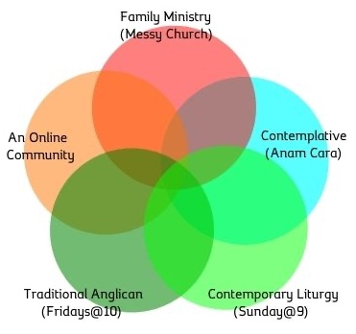
We develop multiple worshipping communities or congregations within the one parish.
We aim to offer different styles of Anglican worship including
- Intergenerational family ministry
- Contemplative
- Online
- Traditional
- Contemporary liturgy

Our Mission goals (what we do to achieve our vision)
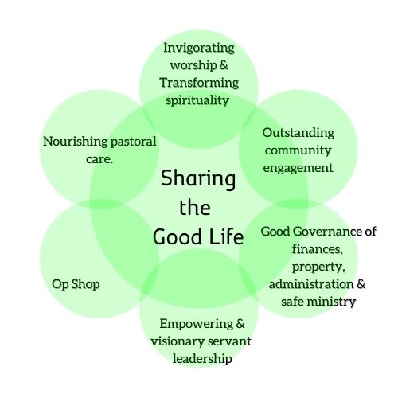
In sharing the Good Life, we cultivate:
Invigorating worship & transforming spirituality.

Outstanding community engagement

Nourishing pastoral care.

Empowering & visionary servant leadership

Good Governance of property, finances, administration
and a Safe Church Culture.

Rule of life (when ministry happens)
A rule of life is a regular routine that includes day-to-day habits that achieve the mission goals.
Event | Day, Time, Frequency | Coordinator
Sundays @ 9 | Every Sunday | Helen Nicholson
Messy Church | 4th Sundays 4 pm – 6 pm | Barry Campey
Op Shop | Every Mon, Wed & Thurs 9 am – 3 pm | Phil Cowie
Mothers’ Union | 3rd Mon 9.30 am | Joyce Shepherd
Anam Cara Intercessory | Every Mon 10-10.30am | Desiree Snyman
Staff meeting | 4th Monday 11 am | Desiree Snyman
Sew Helpful | 1st and 3rd Mon 1 pm – 4 pm (school Terms) | Lorna Simpson
Life groups | (Variable) | Greg Ezzy
SDA | 3rd Tue 10.30 am | Barbara Fewtrell
Anam Cara | Wed 9 am – 10.30 am | Charlie Handley
Ministry Staff Meeting | Every Wed 11am – 11.30 am | Desiree Snyman
Pastoral Care | 1st Wed 11 am  (Feb, April, June, Aug, Oct) | Lynne Watt
Property | 1st Wed 3.30 pm | Phil Cowie
Messy Church Team | 1st Wed 4 pm | Barry Campey
S@9 Hub | 1st Wed 6pm  (Feb, May, Sep) | Helen Nicholson
Finance Committee | 2nd Wed 11 am  (April, August) | Jo Brooks
Social Committee | TBC | Amanda Middleton
Parish Council | 3rd Wed 6 pm | Charlie Handley
Maranoa | 4th Wed 10 am | Barbara Fewtrell
Executive | 4th Wed 4 pm | Desiree Snyman
Sacristy | 5th Wed 11 am | Lyn Stuckey
Play Place | Thurs 9.30 am – 11.30 am.  School term only | Margaret Brown
Op Shop team | 1st Thurs 3.30 pm | Phil Cowie
Fellowship Group | 2nd Thursday Lunch 12 pm – 1 pm, Bungaraya | Carol Vidal
Anam Cara | Thurs 6 pm – 7 pm | Doug Bannerman
Anam Cara Healing Service | 2nd Thursday 6pm followed by a meal | Doug Bannerman
10am Friday Service | Fri 10 am | Geoff Vidal
Anam Cara Hub | 1st Sat 4pm: Feb, May, Aug | Desiree Snyman
CoVe Committee  (Community on the Verge) | 2nd Sat 4pm: March, June September | Alan Larsen
Annual events | Mini Fetes (May and November),  Office Social (June),  Op Shop Lunch (July & Dec)  Mowing and cleaning rostered annually | Parish Council

Portfolios (the structure of our ministry)
Mission and Ministry happens in teams called Portfolios.
Portfolios are clusters of ministries, programs or activities that are grouped together for:
- good communication
- support through networking & debriefing
- and achieving common goals.
Portfolio | Purpose
Pastoral Care | To show Christ’s love in action.
Worship & Spirituality | To glorify God, proclaim the good news and pursue peace and reconciliation through personal and social spiritual transformation.
Community engagement (outreach and communication) | To respond to human need by loving service.
Op Shop | To respond to human need by loving service.
Leadership | To implement the vision, mission, values and to work towards strategic goals.
Good governance:  Finance, Administration, Safe Ministry and Property | To have outstanding facilities and sustainable resources for mission & ministry.

Our Mission Goals and Portfolio System
The Mission Goals form the portfolio structure of our church in sharing the Good Life.
In a portfolio ministry system, all ministers are cared for in community; no one minister is left isolated. The motivation behind the portfolio system is to equip, encourage and empower the ministers (all the Baptized) to do the work of love that God has called them to do. Our inspiration for a portfolio system is the inner love life of the Trinity, three Persons loving each other so much that they become One.

Mission Goals explained with Marks of Mission
The mission goals are defined with reference to the Marks of Mission as identified by the worldwide Anglican Communion. The Marks of Mission express the Anglican Communion’s common commitment to, and understanding of, God’s holistic and integral mission. Our mission goals describe how we partner with God in sharing the Good life, a clear purpose statement is given for each mission goal.

Mission Goals explained with Marks of Mission
Mission Goal | Explanation | Purpose | Marks of mission
Empowering & visionary servant leadership | The ministers in the church are the Baptized. Each minister is called to shine as a light for Christ in the world.  Empowering Leadership is about encouraging, enabling, equipping, and empowering the people of God. Empowering leaders equip others through effective:  Explanation, motivation, and liberation. | To implement the vision and mission of the church. | To transform unjust structures of society, to challenge violence of every kind and pursue peace and reconciliation.
Invigorating diverse worship  Transforming, flourishing spirituality. | Invigorating worship is to be inspired and energized through glorifying God. Invigorating worship means a high quality of worship in three areas: liturgy, praise, and teaching.  Transforming, flourishing spirituality is committed, energetic, alive, and enthusiastic. Enthusiastic comes from two Greek words which put together mean “in God”. | To glorify God | To proclaim the Good News of the Kingdom.  To teach, baptize and nurture new believers.
Nourishing pastoral care. | Nourishing pastoral care is the love of Christ in action. Joy, laughter, a positive mood, enjoyment: these are but some of the symptoms of pastoral care in the lives of individuals and the church. | To show Christ’s love in action | To respond to human need by loving service.
Outstanding community engagement | Outstanding community engagement is our term for outreach where we respond to human need in the wider community with justice, compassion, and dignity.  Clear, creative, and correct communication and marketing is a necessary driver in our community engagement. | To actively engage the community  we serve with compassionate programs and effective communication. | To respond to human need by loving service  To transform unjust structures of society, to challenge violence of every kind and pursue peace and reconciliation
Good Governance of finances, property, admin. and  safe ministry. | Good Governance is to have effective administration, outstanding facilities, sound finances and safe ministry practices where the most vulnerable are looked after. | To have outstanding facilities and sustainable resources for mission & ministry | To transform unjust structures of society, to challenge violence of every kind and pursue peace and reconciliation
Op Shop | To offer quality furniture, household good and clothing at reasonable prices. |  | To respond to human need by loving service.

Our Values
What follows are the best words that we can offer to describe what we love best about Alstonville Anglicans. The values are a statement of how we view you and ourselves, and every stranger that God sends us, who is a friend in waiting. When you come to us and when we go to you, this is what we are thinking and feeling about you. The best news is that there is little for each of you to do, except to be who you already are. Each of you are beloved original blessings. Each of you belong to God and each other. Aware of your inner being, you believe in loving, life-giving and liberating ways. You are a blessing to others, making life even more beautiful for them. This is the energy of Alstonville Anglicans: beloved, belonging, being, believing, blessing.

Beloved:
each person comes into the world as an original blessing from God.
Thus, each person is a beloved person: significant, wanted and loved.

Belonging:
anyone who wants to belong already belongs. We want to welcome each other as a gift, saying,
“my greatest difference from you is my greatest gift to you”. Community matters and is protected.
We want to consciously enjoy each other hearing “the Christ in me sees the Christ in you.”

Being:
we are human beings not human doings. Our being present is important.
The Spirit of God vibrates within us “like a pure diamond, blazing with the invisible light of heaven.”

Believing:
we are partners with God in living heaven on earth now.
We want to be one call among many, offering a provocative but compassionate voice calling for a whole new way of thinking and believing that is loving, liberating and lifegiving.

Blessing:
As beloved original blessings, we are blessed to be a blessing to others. God is always on God’s way through us to creation, of which humans are a part.
We believe everyone is called, that everyone has something beautiful to do for God.
We want to be the sort of beloved community that creates space for people to express their calling.

